|  |  |
| --- | --- |
| **NAME** | ARAVINTH S |
| **REGISTERNUMBER** | 812620104010 |
| **NMID** | F48D008262C21C4944B4A4069F6C6AB9 |
| **ASSIGNMENT-4** | |

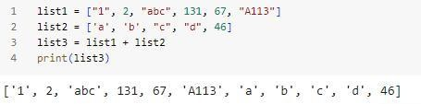Task-1 Createtwolists andjointhosetwolists

Task-2 WithIFstatement find theevennumbers

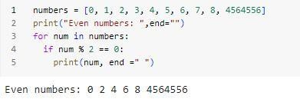

# Task-3 Createa dictionarywith 3keysand 2valuesforeachkey

Task-4 CreateafunctionwithIFstatementwhichis usedtofind theodd numbers

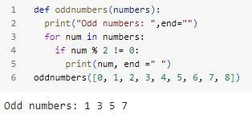

Task-5 WriteaPythonfunctiontosumallthenumbers inalist.

# SampleList:(8,2,3,0,7)ExpectedOutput:20

